COMMON WRITING ASSESSMENT

GRADE 1
QUARTER 1

Name: ___________________
Date:_____________________

Task and Genre
Task- Describe where you live.
Genre- Informational

Differentiation: What is the task at each ELP level?
1  Entering | Draw and label a picture of where you live.  Expectations: Beginning and ending sounds and copy words from bank. Native language may be used.
2  Beginning | Draw and label a picture of where you live and write two sentences with starter “My house has”.  Expectations: Complete sentence starters with most sounds and/or use of word bank.
3  Developing | Draw and label where you live and write two sentences with different starters “My house has” and “My house is”.  Expectations: Form phrases or simple sentences that make sense and use word bank.
4  Expanding | Draw and describe where you live and write 2 sentences. Sentence starters provided for students to choose.  Expectations: Produce 2 connected ideas that make sense and use word bank
5  Bridging/Reaching  (FLEP, non-ELL) | Draw and describe where you live.  Expectations: Produce 2 or more sentences with connected ideas.

Cognitive Function  To remember/understand the details of where they live. | Language Function  To describe where they live.
Supports for each ELP level:

1 | Whole class brainstorm, letter chart* and picture word bank (see attached), work with teacher (choice of group or 1-on-1), translate specific words proposed by students to add to word bank or write on board.
2 | Whole class brainstorm, letter chart* and picture word bank (see attached), same sentence starters, group with teacher, translate specific words proposed by students to add to word bank or write on board.
3 | Whole class brainstorm, letter chart*, 2 different sentence starters, modeling/reminder word bank
4 | Whole class brainstorm, letter chart*, various sentence starters, word bank
5 | Whole class brainstorm and letter chart*

*Letter Chart- Use fundations chart or a chart you frequently use in your classroom

Picture Word Bank
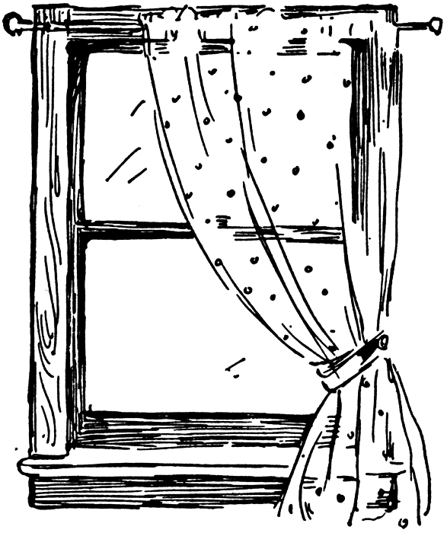
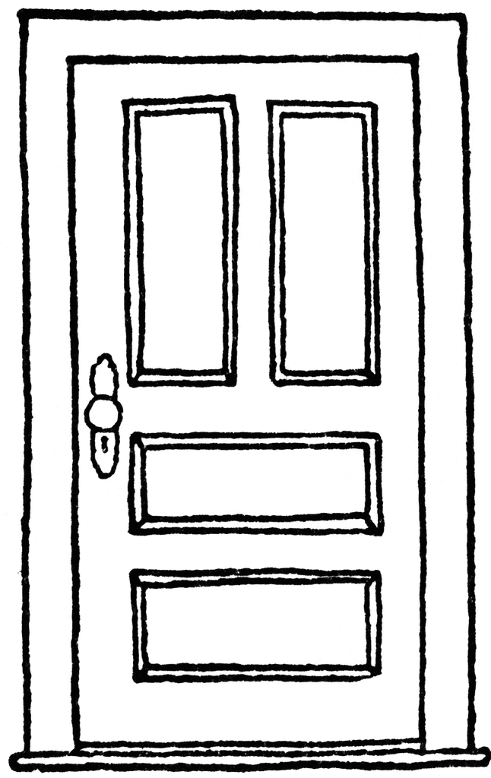
a window

a door
a kitchen

a living room
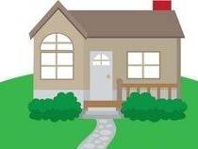
a bathroom
a bedroom

a yard

G1/Q1/L1
Draw a picture of where you live. Label the picture. Use the picture word bank to help you.

G1/Q1/L2
Describe where you live. Draw a picture to match. Use the picture word bank to help you.

_____________________________________________________
My house has

_ _ _ _ _ _ _ _ _ _ _ _ _ _ _ _ _ _ _ _ _ _ _ _ _ _ _ _ _ _ _ _ _ _ _
_____________________________________________________
_____________________________________________________
_ _ _ _ _ _ _ _ _ _ _ _ _ _ _ _ _ _ _ _ _ _ _ _ _ _ _ _ _ _ _ _ _ _ _
_____________________________________________________
_____________________________________________________
My house has

_ _ _ _ _ _ _ _ _ _ _ _ _ _ _ _ _ _ _ _ _ _ _ _ _ _ _ _ _ _ _ _ _ _ _
_____________________________________________________
_____________________________________________________
_ _ _ _ _ _ _ _ _ _ _ _ _ _ _ _ _ _ _ _ _ _ _ _ _ _ _ _ _ _ _ _ _ _ _
_____________________________________________________
G1/Q1/L3

Word Bank
a room a window a door a yard
a house a kitchen a street an apartment
large small old new
white blue green gray
one two three four

G1/Q1/L3

Describe where you live. Draw a picture to match.

_____________________________________________________
My house has

_ _ _ _ _ _ _ _ _ _ _ _ _ _ _ _ _ _ _ _ _ _ _ _ _ _ _ _ _ _ _ _ _ _ _
_____________________________________________________
_____________________________________________________
_ _ _ _ _ _ _ _ _ _ _ _ _ _ _ _ _ _ _ _ _ _ _ _ _ _ _ _ _ _ _ _ _ _ _
_____________________________________________________
_____________________________________________________
My house is

_ _ _ _ _ _ _ _ _ _ _ _ _ _ _ _ _ _ _ _ _ _ _ _ _ _ _ _ _ _ _ _ _ _ _
_____________________________________________________
_____________________________________________________
_ _ _ _ _ _ _ _ _ _ _ _ _ _ _ _ _ _ _ _ _ _ _ _ _ _ _ _ _ _ _ _ _ _ _
_____________________________________________________

G1/Q1/L4
Describe where you live. Draw a picture to match.
Word Bank
a room a window a door a yard
a house a kitchen a street an apartment
large small old new

white blue green gray
one two three four

G1/Q1/L4

Sentence Starters
My house... | I live... | My bedroom...

_____________________________________________________
_ _ _ _ _ _ _ _ _ _ _ _ _ _ _ _ _ _ _ _ _ _ _ _ _ _ _ _ _ _ _ _ _ _ _
_____________________________________________________
_____________________________________________________
_ _ _ _ _ _ _ _ _ _ _ _ _ _ _ _ _ _ _ _ _ _ _ _ _ _ _ _ _ _ _ _ _ _ _
_____________________________________________________
_____________________________________________________
_ _ _ _ _ _ _ _ _ _ _ _ _ _ _ _ _ _ _ _ _ _ _ _ _ _ _ _ _ _ _ _ _ _ _
_____________________________________________________
_____________________________________________________
_ _ _ _ _ _ _ _ _ _ _ _ _ _ _ _ _ _ _ _ _ _ _ _ _ _ _ _ _ _ _ _ _ _ _
_____________________________________________________

G1/Q1/L5
Describe where you live. Draw a picture to match.

_____________________________________________________
_ _ _ _ _ _ _ _ _ _ _ _ _ _ _ _ _ _ _ _ _ _ _ _ _ _ _ _ _ _ _ _ _ _ _
_____________________________________________________
_____________________________________________________
_ _ _ _ _ _ _ _ _ _ _ _ _ _ _ _ _ _ _ _ _ _ _ _ _ _ _ _ _ _ _ _ _ _ _
_____________________________________________________
_____________________________________________________
_ _ _ _ _ _ _ _ _ _ _ _ _ _ _ _ _ _ _ _ _ _ _ _ _ _ _ _ _ _ _ _ _ _ _
_____________________________________________________
_____________________________________________________
_ _ _ _ _ _ _ _ _ _ _ _ _ _ _ _ _ _ _ _ _ _ _ _ _ _ _ _ _ _ _ _ _ _ _
_____________________________________________________
_____________________________________________________
_ _ _ _ _ _ _ _ _ _ _ _ _ _ _ _ _ _ _ _ _ _ _ _ _ _ _ _ _ _ _ _ _ _ _
__________________________________________________________________________________________________________
_ _ _ _ _ _ _ _ _ _ _ _ _ _ _ _ _ _ _ _ _ _ _ _ _ _ _ _ _ _ _ _ _ _ _
_____________________________________________________

