COMMON WRITING ASSESSMENT

GRADE 2
QUARTER 1

Name: ___________________
Date:_____________________

Task and Genre
Task- Describe where you live.
Genre- Informational

Differentiation: What is the task at each ELP level?
1 | Draw and label a picture of where you live. Complete the sentence frame.  Expectations: Beginning and ending sounds and copying words from bank.
2 | Draw a picture of where you live and write two sentences with different starters “My house has” and “My house is”.  Expectations: Phrases and use of word bank to form simple sentences that make sense.
3 | Draw and describe where you live and write 2 sentences. Sentence starters provided for students to choose.  Expectations: Form 2 simple sentences using the work bank that make sense.
4 | Draw and describe where you live using 3 or more sentences.  Expectations: Produce original sentences that make sense and use of word bank.
5 | Draw and describe where you live using 5 or more sentences.  Expectations: Produces 5 or more sentences that are connected and at least one compound sentence. Checks work with provided writing checklist.

Cognitive Function  To remember/understand the details of where they live. | Language Function  To describe where they live.
Supports for each ELP level:

1 | Whole class brainstorm, letter chart*, picture word bank (see attached) sentence frame, and work with a teacher (choice of group or 1 on 1).
2 | Whole class brainstorm, letter chart* and picture word bank (see attached), 2 different sentence starters, group with teacher.
3 | Whole class brainstorm, letter chart*, 3 different sentence starters, model / remind use of word bank.
4 | Whole class brainstorm, letter chart* and, word bank.
5 | Whole class brainstorm and letter chart* and writing checklist

*Letter Chart- Use fundations chart or a chart you frequently use in your classroom

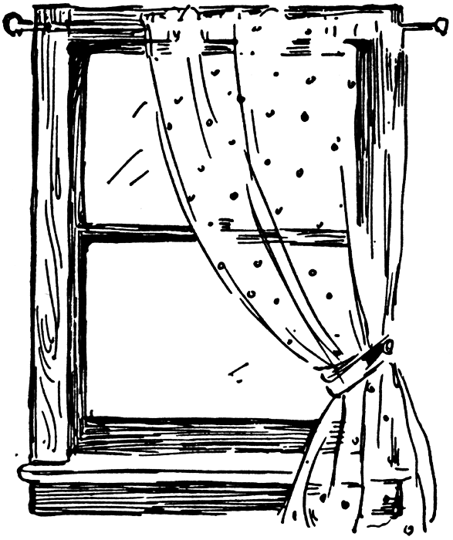
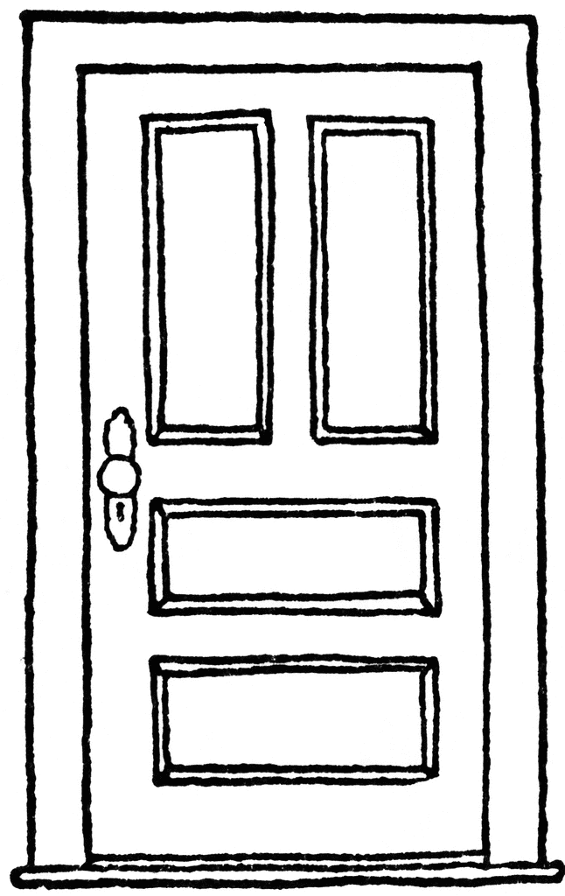
Picture Word Bank
a window
a door
a kitchen
a bedroom

a living room
a bathroom
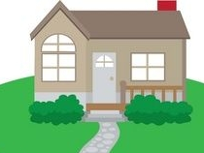

a yard

G2/Q1/L1

Draw a picture of where you live. Label the picture. Use the picture word bank to help you.

_____________________________________________________
My house has

_ _ _ _ _ _ _ _ _ _ _ _ _ _ _ _ _ _ _ _ _ _ _ _ _ _ _ _ _ _ _ _ _ _ _
_____________________________________________________
_____________________________________________________
_ _ _ _ _ _ _ _ _ _ _ _ _ _ _ _ _ _ _ _ _ _ _ _ _ _ _ _ _ _ _ _ _ _ _

G2/Q1/L2
Describe where you live. Draw a picture to match. Use the picture word bank to help you.

_____________________________________________________
My house has

_ _ _ _ _ _ _ _ _ _ _ _ _ _ _ _ _ _ _ _ _ _ _ _ _ _ _ _ _ _ _ _ _ _ _
_____________________________________________________
_____________________________________________________
_ _ _ _ _ _ _ _ _ _ _ _ _ _ _ _ _ _ _ _ _ _ _ _ _ _ _ _ _ _ _ _ _ _ _
_____________________________________________________
_____________________________________________________
My house is

_ _ _ _ _ _ _ _ _ _ _ _ _ _ _ _ _ _ _ _ _ _ _ _ _ _ _ _ _ _ _ _ _ _ _
_____________________________________________________
_____________________________________________________
_ _ _ _ _ _ _ _ _ _ _ _ _ _ _ _ _ _ _ _ _ _ _ _ _ _ _ _ _ _ _ _ _ _ _
_____________________________________________________
G2/Q1/L3
Describe where you live. Write 2 sentences. Draw a picture to match.
Word Bank
a room a window a door a yard
a house a kitchen a street an apartment

Sentence Starters
My house___________ | I live___________ | My bedroom________
____________________________________________________
_ _ _ _ _ _ _ _ _ _ _ _ _ _ _ _ _ _ _ _ _ _ _ _ _ _ _ _ _ _ _ _ _ _ _
_____________________________________________________
_____________________________________________________
_ _ _ _ _ _ _ _ _ _ _ _ _ _ _ _ _ _ _ _ _ _ _ _ _ _ _ _ _ _ _ _ _ _ _
_____________________________________________________
_____________________________________________________
_ _ _ _ _ _ _ _ _ _ _ _ _ _ _ _ _ _ _ _ _ _ _ _ _ _ _ _ _ _ _ _ _ _ _
_____________________________________________________
_____________________________________________________
_ _ _ _ _ _ _ _ _ _ _ _ _ _ _ _ _ _ _ _ _ _ _ _ _ _ _ _ _ _ _ _ _ _ _
_____________________________________________________
_____________________________________________________
_ _ _ _ _ _ _ _ _ _ _ _ _ _ _ _ _ _ _ _ _ _ _ _ _ _ _ _ _ _ _ _ _ _ _
_____________________________________________________
G2/Q1/L4
Describe where you live. Write 3 or more sentences. Draw a picture to match.
Word Bank
a room a window a door a yard
a house a kitchen a street an apartment

____________________________________________________________
_ _ _ _ _ _ _ _ _ _ _ _ _ _ _ _ _ _ _ _ _ _ _ _ _ _ _ _ _ _ _ _ _ _ _ _ _ _ _ _
________________________________________________________________________________________________________________________
_ _ _ _ _ _ _ _ _ _ _ _ _ _ _ _ _ _ _ _ _ _ _ _ _ _ _ _ _ _ _ _ _ _ _ _ _ _ _ _
____________________________________________________________
____________________________________________________________
_ _ _ _ _ _ _ _ _ _ _ _ _ _ _ _ _ _ _ _ _ _ _ _ _ _ _ _ _ _ _ _ _ _ _ _ _ _ _ _
________________________________________________________________________________________________________________________
_ _ _ _ _ _ _ _ _ _ _ _ _ _ _ _ _ _ _ _ _ _ _ _ _ _ _ _ _ _ _ _ _ _ _ _ _ _ _ _
________________________________________________________________________________________________________________________
_ _ _ _ _ _ _ _ _ _ _ _ _ _ _ _ _ _ _ _ _ _ _ _ _ _ _ _ _ _ _ _ _ _ _ _ _ _ _ _
________________________________________________________________________________________________________________________
_ _ _ _ _ _ _ _ _ _ _ _ _ _ _ _ _ _ _ _ _ _ _ _ _ _ _ _ _ _ _ _ _ _ _ _ _ _ _ _
____________________________________________________________

G2/Q1/L5
Describe where you live. Write 5 or more sentences. Draw a picture to match.

____________________________________________________________
_ _ _ _ _ _ _ _ _ _ _ _ _ _ _ _ _ _ _ _ _ _ _ _ _ _ _ _ _ _ _ _ _ _ _ _ _ _ _ _
________________________________________________________________________________________________________________________
_ _ _ _ _ _ _ _ _ _ _ _ _ _ _ _ _ _ _ _ _ _ _ _ _ _ _ _ _ _ _ _ _ _ _ _ _ _ _ _
____________________________________________________________
____________________________________________________________
_ _ _ _ _ _ _ _ _ _ _ _ _ _ _ _ _ _ _ _ _ _ _ _ _ _ _ _ _ _ _ _ _ _ _ _ _ _ _ _
________________________________________________________________________________________________________________________
_ _ _ _ _ _ _ _ _ _ _ _ _ _ _ _ _ _ _ _ _ _ _ _ _ _ _ _ _ _ _ _ _ _ _ _ _ _ _ _
________________________________________________________________________________________________________________________
_ _ _ _ _ _ _ _ _ _ _ _ _ _ _ _ _ _ _ _ _ _ _ _ _ _ _ _ _ _ _ _ _ _ _ _ _ _ _ _
________________________________________________________________________________________________________________________
_ _ _ _ _ _ _ _ _ _ _ _ _ _ _ _ _ _ _ _ _ _ _ _ _ _ _ _ _ _ _ _ _ _ _ _ _ _ _ _
____________________________________________________________
G2/Q1/L4-5
____________________________________________________________
_ _ _ _ _ _ _ _ _ _ _ _ _ _ _ _ _ _ _ _ _ _ _ _ _ _ _ _ _ _ _ _ _ _ _ _ _ _ _ _
________________________________________________________________________________________________________________________
_ _ _ _ _ _ _ _ _ _ _ _ _ _ _ _ _ _ _ _ _ _ _ _ _ _ _ _ _ _ _ _ _ _ _ _ _ _ _ _
____________________________________________________________
____________________________________________________________
_ _ _ _ _ _ _ _ _ _ _ _ _ _ _ _ _ _ _ _ _ _ _ _ _ _ _ _ _ _ _ _ _ _ _ _ _ _ _ _
________________________________________________________________________________________________________________________
_ _ _ _ _ _ _ _ _ _ _ _ _ _ _ _ _ _ _ _ _ _ _ _ _ _ _ _ _ _ _ _ _ _ _ _ _ _ _ _
________________________________________________________________________________________________________________________
_ _ _ _ _ _ _ _ _ _ _ _ _ _ _ _ _ _ _ _ _ _ _ _ _ _ _ _ _ _ _ _ _ _ _ _ _ _ _ _
________________________________________________________________________________________________________________________
_ _ _ _ _ _ _ _ _ _ _ _ _ _ _ _ _ _ _ _ _ _ _ _ _ _ _ _ _ _ _ _ _ _ _ _ _ _ _ _
________________________________________________________________________________________________________________________
_ _ _ _ _ _ _ _ _ _ _ _ _ _ _ _ _ _ _ _ _ _ _ _ _ _ _ _ _ _ _ _ _ _ _ _ _ _ _ _
________________________________________________________________________________________________________________________
_ _ _ _ _ _ _ _ _ _ _ _ _ _ _ _ _ _ _ _ _ _ _ _ _ _ _ _ _ _ _ _ _ _ _ _ _ _ _ _
____________________________________________________________
____________________________________________________________
_ _ _ _ _ _ _ _ _ _ _ _ _ _ _ _ _ _ _ _ _ _ _ _ _ _ _ _ _ _ _ _ _ _ _ _ _ _ _ _
________________________________________________________________________________________________________________________
_ _ _ _ _ _ _ _ _ _ _ _ _ _ _ _ _ _ _ _ _ _ _ _ _ _ _ _ _ _ _ _ _ _ _ _ _ _ _ _
________________________________________________________________________________________________________________________
_ _ _ _ _ _ _ _ _ _ _ _ _ _ _ _ _ _ _ _ _ _ _ _ _ _ _ _ _ _ _ _ _ _ _ _ _ _ _ _
____________________________________________________________
G2/Q1/L5

Writing Checklist

I put a capital letter at the beginning of my sentences.
I put punctuation at the end of my sentence.
I put more than one idea in my sentence.
I reread my sentences.
I wrote 5 sentences.

