Step 1:
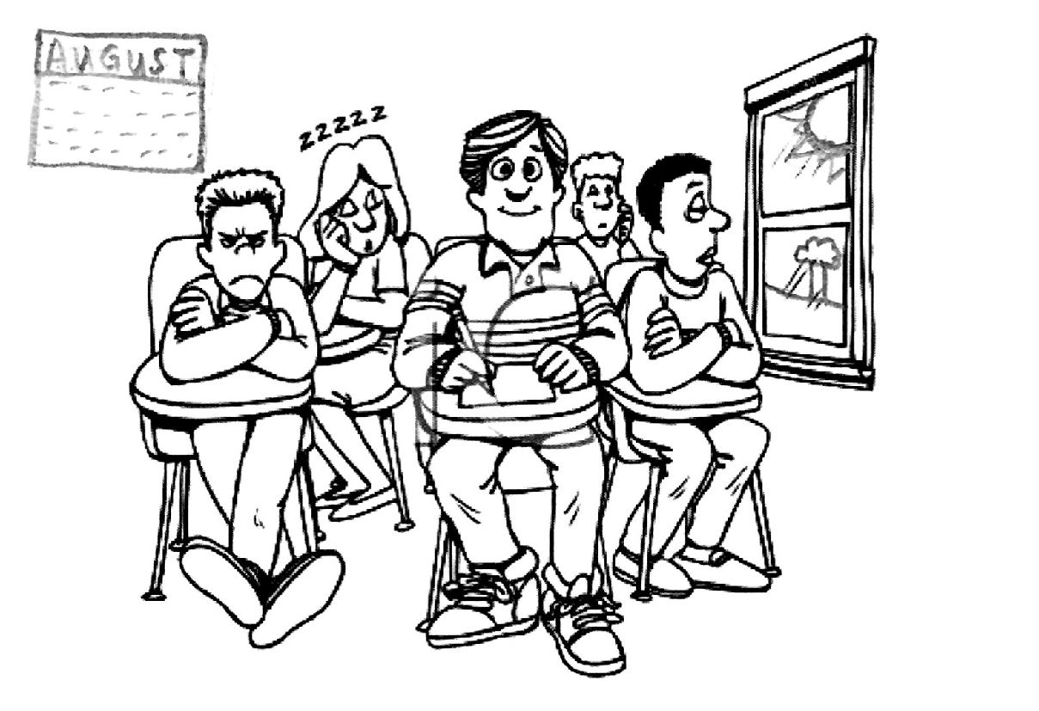
Think about this question: Should we have school all year?

Step 2:
Write your opinion here. Give 3 reasons.
I think ______________________________________________________
___________________________________________________________.
My first reason is _____________________________________________
___________________________________________________________.
My second reason is___________________________________________
___________________________________________________________.
My third reason is _____________________________________________
___________________________________________________________.

Step 2: Now read your writing and ask yourself:
Did I write complete sentences?

Did I include 3 reasons?

Did I use words from the word bank?

Reasons  vacation  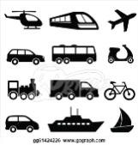  travel  learn  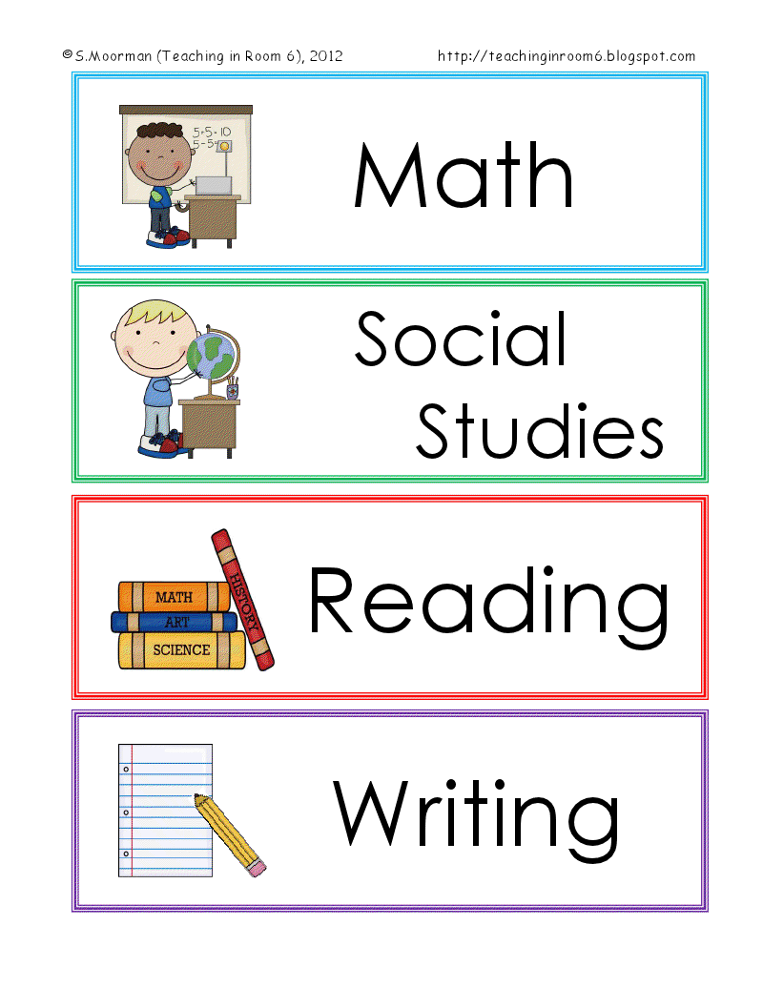  schedule  camp  play  sports  read  relax | Adjectives  fun  hot  boring  interesting  exciting  difficult  tiring  relaxing

