Common Writing Assessment

Grade: 2 Quarter: 3

Task: Choose your favorite part of the school day. Explain why you like that part of the day.
Genre: Opinion
Cognitive Function
Students will decide on a favorite subject (includes specialist and recess) and develop reasons to support their opinion.
Language Function:
Students will name a subject and explain why they prefer this subject in writing.
ELP Level | Differentiation | Support
1 | Draw and label your picture. Give one reason for choosing that part of the day.  Expectations: Beginning and ending sounds and copy words from bank. Native language may be used. Orally telling reason or using picture clues to help. | Whole class brainstorm, letter chart and picture word bank (see attached), work with teacher (choice of group or 1-on-1)
2 | Draw and label your picture. Write one reason for choosing that part of the day.  Expectations: Complete sentence starter with most sounds and/or use of word bank. | Whole class brainstorm, letter chart and picture word bank (see attached), sentence frame with conjunction, group with teacher
3 | Draw your favorite part of your school day and write two sentences including one reason supporting your opinion.  Expectations: Form 2 phrases or simple sentences with help from the sentence starter that make sense and use word bank. | Whole class brainstorm, letter chart,2 different sentence starters, modeling/reminder word bank
4 | Draw and write about your favorite part of the school day. Write 3 to 5 sentences. Provide 2 or more reasons supporting your opinion. Sentences frames provided  Expectations: State opinion and give 2 reasons that make sense and use word bank | Whole class brainstorm, letter chart, various sentence starters, word bank
5 | Write 5 to 7 sentences telling your favorite part of the school day. Give 3 or more reasons why you like it. Draw a picture to match your words. Expectations: State opinion with 3 reasons that make sense and use word bank | Whole class brainstorm and letter chart
Rubric: WIDA 1-12 Writing Rubric

ELD COMMON WRITING ASSESSMENT
GRADE 2
QUARTER 3: OPINION

Name: _________________________________ Grade: ________________

Date: __________________________________ Class: _________________

Picture Word Bank

math  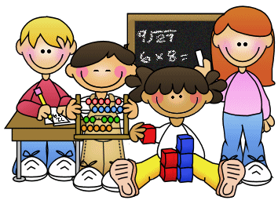 | reading | writing
science | social studies | lunch  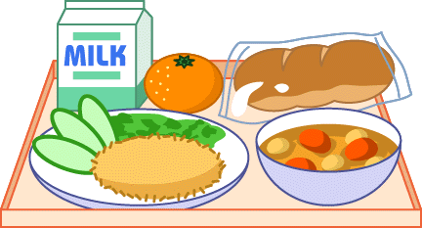
recess  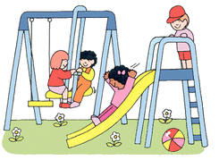 | P.E.  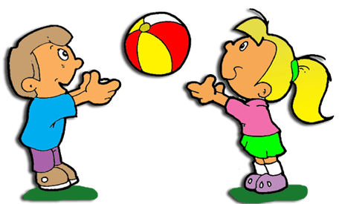 | art  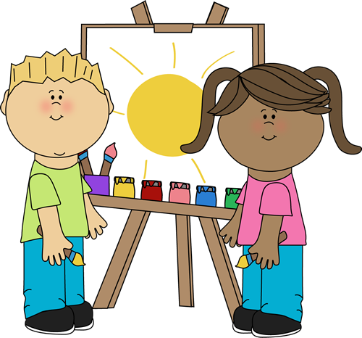
library  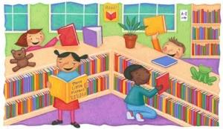 | music | x-block  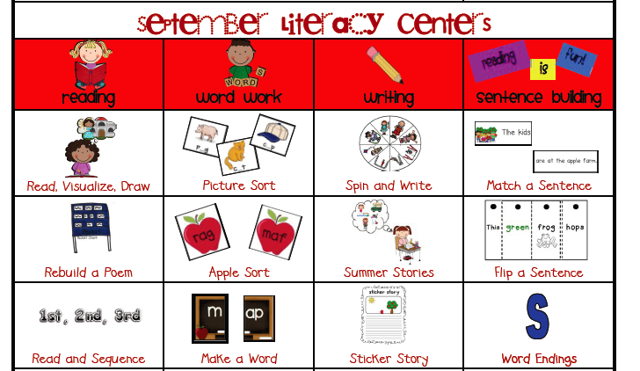
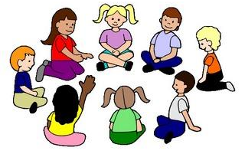  morning meeting | word work  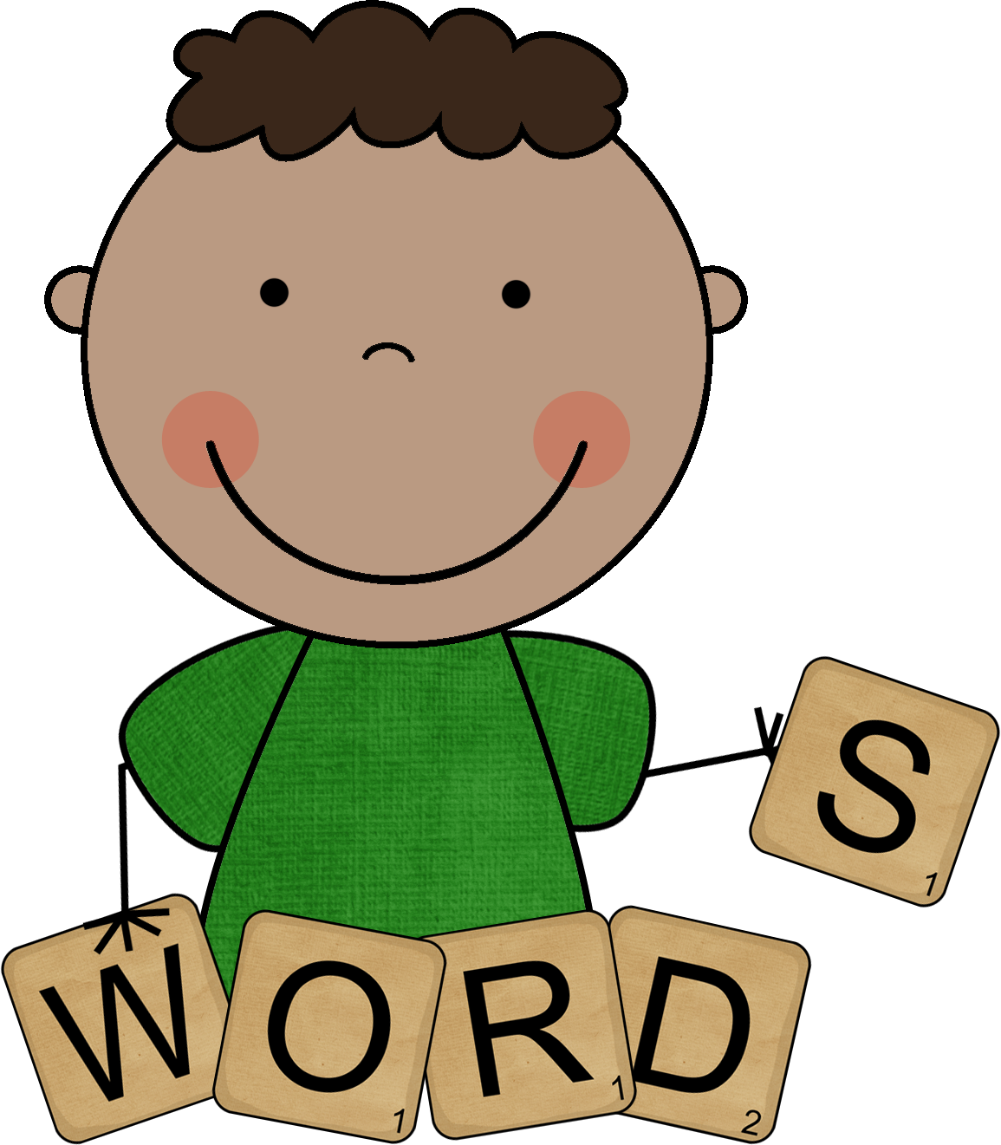

Q3/G2/L1

Draw your favorite part of the school day. Label your picture. Use the word bank to help you.

Why do you like this?

Options:
- Student orally tells teacher reasons. Record answer below.

- Use the picture key below and have a student select a picture for their reason.
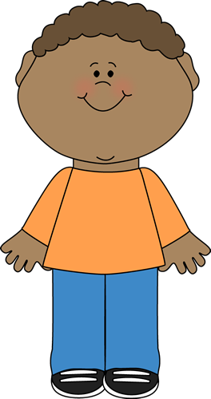

Q3/G2/L2

Draw your favorite part of the school day. Label your picture. Use the word bank to help you.

Tell what part of the day you like. Write why you like this part of the day.
_____________________________________________________
I like because

_ _ _ _ _ _ _ _ _ _ _ _ _ _ _ _ _ _ _ _ _ _ _ _ _ _ _ _ _ _ _ _ _ _ _
_____________________________________________________
_____________________________________________________

_ _ _ _ _ _ _ _ _ _ _ _ _ _ _ _ _ _ _ _ _ _ _ _ _ _ _ _ _ _ _ _ _ _ _
_____________________________________________________

Q3/G2/L3

Draw your favorite part of the school day. Use the word bank.

Word Bank

math | reading | writing
science | social studies | lunch
recess | P.E. | art
library | music | x-block
morning meeting | word work

Write 2 sentences about why you like this part of the school day.
I like because

___________________________________________________
_ _ _ _ _ _ _ _ _ _ _ _ _ _ _ _ _ _ _ _ _ _ _ _ _ _ _ _ _ _ _ _ _ _ _
_____________________________________________________
_____________________________________________________
_ _ _ _ _ _ _ _ _ _ _ _ _ _ _ _ _ _ _ _ _ _ _ _ _ _ _ _ _ _ _ _ _ _ _
_____________________________________________________
_____________________________________________________

_ _ _ _ _ _ _ _ _ _ _ _ _ _ _ _ _ _ _ _ _ _ _ _ _ _ _ _ _ _ _ _ _ _ _
_____________________________________________________
_____________________________________________________
_ _ _ _ _ _ _ _ _ _ _ _ _ _ _ _ _ _ _ _ _ _ _ _ _ _ _ _ _ _ _ _ _ _ _
_____________________________________________________

Q3/G2/L4
Draw your favorite part of the school day. Use the word bank.

Word Bank
math | reading | writing
science | social studies | lunch
recess | P.E. | art
library | music | x-block
morning meeting | word work

Write 3 to 5 sentences telling your favorite part of the school day. Give 2 or more reasons why you like it.
Sentence Frames
I like ___________ because_________ | My favorite subject is _______________ because___________ | I like_____ because ______ and _______.
________________________________________________________________________________________________
_ _ _ _ _ _ _ _ _ _ _ _ _ _ _ _ _ _ _ _ _ _ _ _ _ _ _ _ _ _ _ _ _ _ _ _
_____________________________________________________
_________________________________________________________________________________________________
_ _ _ _ _ _ _ _ _ _ _ _ _ _ _ _ _ _ _ _ _ _ _ _ _ _ _ _ _ _ _ _ _ _ _ _
_____________________________________________________
_________________________________________________________________________________________________
_ _ _ _ _ _ _ _ _ _ _ _ _ _ _ _ _ _ _ _ _ _ _ _ _ _ _ _ _ _ _ _ _ _ _ _
_____________________________________________________

_________________________________________________________________________________________________
_ _ _ _ _ _ _ _ _ _ _ _ _ _ _ _ _ _ _ _ _ _ _ _ _ _ _ _ _ _ _ _ _ _ _ _
_____________________________________________________
_________________________________________________________________________________________________
_ _ _ _ _ _ _ _ _ _ _ _ _ _ _ _ _ _ _ _ _ _ _ _ _ _ _ _ _ _ _ _ _ _ _ _
_____________________________________________________
_____________________________________________________
_ _ _ _ _ _ _ _ _ _ _ _ _ _ _ _ _ _ _ _ _ _ _ _ _ _ _ _ _ _ _ _ _ _ _ _
_____________________________________________________

Q3/G1/L5
Write 5 to 7 sentences telling your favorite part of the school day. Give 3 or more reasons why you like it. Draw a picture to match your words.

________________________________________________________________________________________________
_ _ _ _ _ _ _ _ _ _ _ _ _ _ _ _ _ _ _ _ _ _ _ _ _ _ _ _ _ _ _ _ _ _ _ _
_____________________________________________________
_________________________________________________________________________________________________
_ _ _ _ _ _ _ _ _ _ _ _ _ _ _ _ _ _ _ _ _ _ _ _ _ _ _ _ _ _ _ _ _ _ _ _
_____________________________________________________
_________________________________________________________________________________________________
_ _ _ _ _ _ _ _ _ _ _ _ _ _ _ _ _ _ _ _ _ _ _ _ _ _ _ _ _ _ _ _ _ _ _ _
_____________________________________________________
________________________________________________________________________________________________
_ _ _ _ _ _ _ _ _ _ _ _ _ _ _ _ _ _ _ _ _ _ _ _ _ _ _ _ _ _ _ _ _ _ _ _
_____________________________________________________
_________________________________________________________________________________________________
_ _ _ _ _ _ _ _ _ _ _ _ _ _ _ _ _ _ _ _ _ _ _ _ _ _ _ _ _ _ _ _ _ _ _ _
_____________________________________________________
_________________________________________________________________________________________________
_ _ _ _ _ _ _ _ _ _ _ _ _ _ _ _ _ _ _ _ _ _ _ _ _ _ _ _ _ _ _ _ _ _ _ _
_____________________________________________________
________________________________________________________________________________________________
_ _ _ _ _ _ _ _ _ _ _ _ _ _ _ _ _ _ _ _ _ _ _ _ _ _ _ _ _ _ _ _ _ _ _ _
_____________________________________________________
_________________________________________________________________________________________________
_ _ _ _ _ _ _ _ _ _ _ _ _ _ _ _ _ _ _ _ _ _ _ _ _ _ _ _ _ _ _ _ _ _ _ _
_____________________________________________________

Extra paper for L4-5
_________________________________________________________________________________________________
_ _ _ _ _ _ _ _ _ _ _ _ _ _ _ _ _ _ _ _ _ _ _ _ _ _ _ _ _ _ _ _ _ _ _ _
_____________________________________________________
________________________________________________________________________________________________
_ _ _ _ _ _ _ _ _ _ _ _ _ _ _ _ _ _ _ _ _ _ _ _ _ _ _ _ _ _ _ _ _ _ _ _
_____________________________________________________
_________________________________________________________________________________________________
_ _ _ _ _ _ _ _ _ _ _ _ _ _ _ _ _ _ _ _ _ _ _ _ _ _ _ _ _ _ _ _ _ _ _ _
_____________________________________________________
_________________________________________________________________________________________________
_ _ _ _ _ _ _ _ _ _ _ _ _ _ _ _ _ _ _ _ _ _ _ _ _ _ _ _ _ _ _ _ _ _ _ _
_____________________________________________________
________________________________________________________________________________________________
_ _ _ _ _ _ _ _ _ _ _ _ _ _ _ _ _ _ _ _ _ _ _ _ _ _ _ _ _ _ _ _ _ _ _ _
_____________________________________________________
_________________________________________________________________________________________________
_ _ _ _ _ _ _ _ _ _ _ _ _ _ _ _ _ _ _ _ _ _ _ _ _ _ _ _ _ _ _ _ _ _ _ _
_____________________________________________________
_________________________________________________________________________________________________
_ _ _ _ _ _ _ _ _ _ _ _ _ _ _ _ _ _ _ _ _ _ _ _ _ _ _ _ _ _ _ _ _ _ _ _
_____________________________________________________
________________________________________________________________________________________________
_ _ _ _ _ _ _ _ _ _ _ _ _ _ _ _ _ _ _ _ _ _ _ _ _ _ _ _ _ _ _ _ _ _ _ _
_____________________________________________________
_________________________________________________________________________________________________
_ _ _ _ _ _ _ _ _ _ _ _ _ _ _ _ _ _ _ _ _ _ _ _ _ _ _ _ _ _ _ _ _ _ _ _
_____________________________________________________
_________________________________________________________________________________________________
_ _ _ _ _ _ _ _ _ _ _ _ _ _ _ _ _ _ _ _ _ _ _ _ _ _ _ _ _ _ _ _ _ _ _ _
_____________________________________________________________________________________________________________________________________________________
_ _ _ _ _ _ _ _ _ _ _ _ _ _ _ _ _ _ _ _ _ _ _ _ _ _ _ _ _ _ _ _ _ _ _ _
_____________________________________________________
_________________________________________________________________________________________________
_ _ _ _ _ _ _ _ _ _ _ _ _ _ _ _ _ _ _ _ _ _ _ _ _ _ _ _ _ _ _ _ _ _ _ _
_____________________________________________________

