Step 1: Think about this question: How would you feel about going to school in the summer?
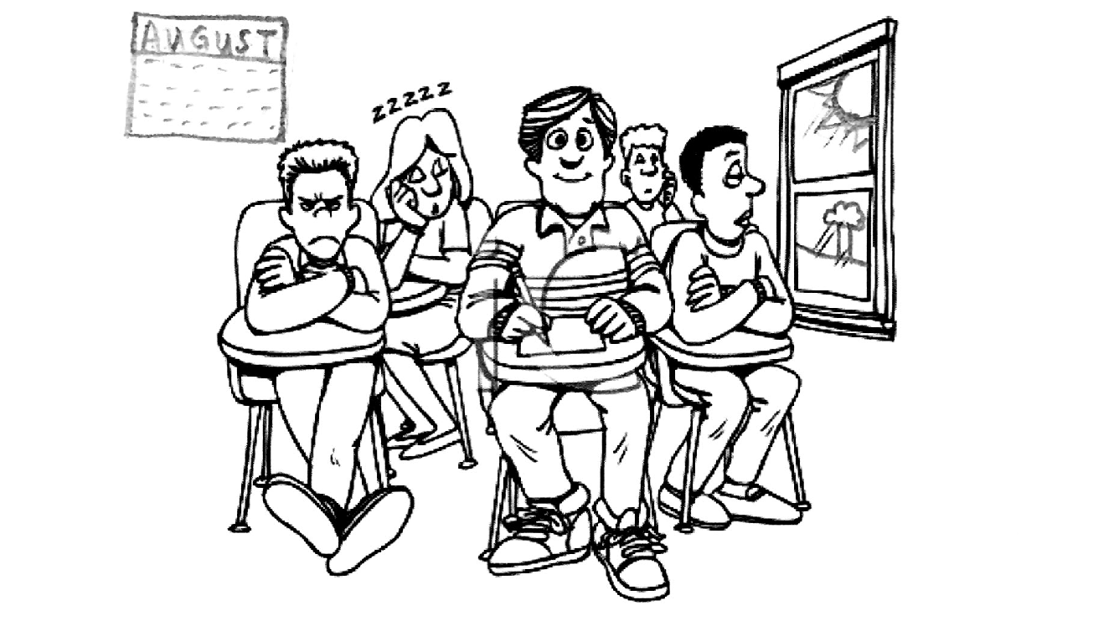
Step 2: Write about how you would feel.
I would feel ________________________________.
School is __________________________________.
Summer is _________________________________.
________________________________________________________________________________________________________________________________________________________________________

Step 2: Now read your writing and ask yourself:
Did I use adjectives?

Did I use words from the word bank?

Did I write sentences?

 | excited
 | tired | smart
Feelings
Adjectives

fun

hot

boring

interesting

exciting

difficult

tiring

relaxing

