Step 1: Should we have school all year? Write your opinion about this question here. Give 3 reasons and information for each reason.
I think ______________________________________________
________________________________________________________________________________________________________
My first reason is _____________________________________
____________________________________________________
because_________________________________________________________________________________________________
My second reason is___________________________________
____________________________________________________
because_________________________________________________________________________________________________
My third reason is _____________________________________
____________________________________________________
because_________________________________________________________________________________________________

Step 2: Now read your writing and ask yourself:
Did I write complete sentences?
Did I include 3 reasons and 3 pieces of information?
Did I use correct ending punctuation?

Word Bank
You can use these words and phrases in your writing:
Reasons  Vacation  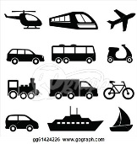  Travel  Holiday  Learn  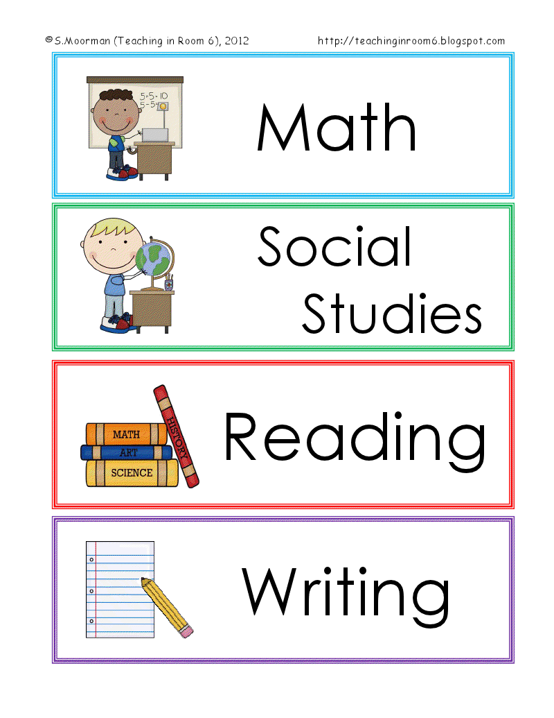  Schedule  Camp  Play  Sports  Read  Relax | Adjectives  Fun  Hot  Boring  Interesting  Exciting  Difficult  Tiring  relaxing

