Juicy Sentences | 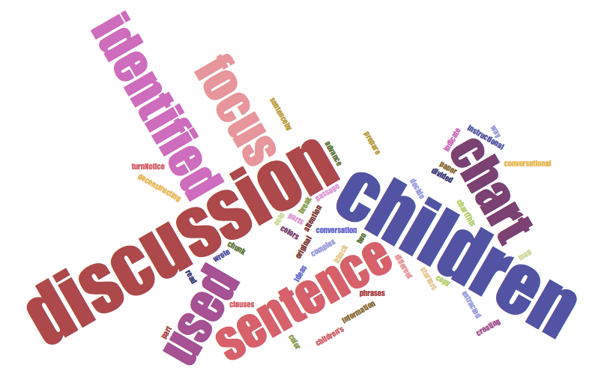
(based on Wong-Fillmore & Snow, 2000)
Juicy sentences are encountered:
- In rich, engaging units of study focused on content topics
- Pulled from COMPLEX read aloud text or close reading
- Focused on language and meaning
- Used to uncover how complex sentences and rare words work together as “academic language”
- Utilize shared inquiry discussion w/ students

_{Elementary Example} | ‘Twas the day before Zoo Day, when all ‘round the park,  The creatures felt restless and wished it were dark.  Zookeepers all scurried to get things prepared…  Ipcizade, Catherine. ‘Twas the Day Before Zoo Day. Mount Pleasant, SC: Sylvan Dell Publishing, 2013.
Middle School Example | Of all the larger predators, wildcats are the most likely to use the same trails again and again. In deep snow, their  habitual routes become gully trails in which the feline tracks going to and coming from their hunting grounds are  preserved, down out of the wind, away from blowing snow.  Arnosky, Jim. Wild Tracks! A Guide to Nature’s Footprints. New York: Sterling, 2008.
High School Example | But such is not the state of the case. I say it with a sad sense of the disparity between us. I am not included within the  pale of glorious anniversary! Your high independence only reveals the immeasurable distance between us. The  blessings in which you, this day, rejoice, are not enjoyed in common. The rich inheritance of justice, liberty, prosperity  and independence, bequeathed by your fathers, is shared by you, not by me.  Douglass, Frederick. “What to the Slave Is the Fourth of July?: An Address Delivered in Rochester, New York, on 5  July 1852.” The Oxford Frederick Douglass Reader. Oxford: Oxford University Press, 1996. (1852)
Instructional Sequence:
- Select a SHORT passage (1-3 sentences) with visual support
- Read passage for and with students (multiple readings)
- Identify rare words/phrases
- Analyze sentences – WH-questions (When, Where, What, Who, How)
- Extend selected rare words throughout the day in teacher and student speech (e.g., word wizards – students are incentivized to use/listen for the selected rare words throughout the day)

